Title: A VR Classroom for Distant Education

Students:

1. Kevinsonh Ahuejere
2. Timothy Oladunni

Faculty: Sharad Sharma, PhD.

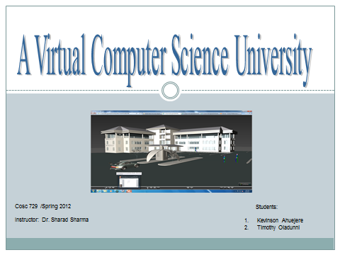

Materials copied from other sites include:

1. Building from Turbosquid - www.**turbosquid**.com/
2. Humans from 3dmax

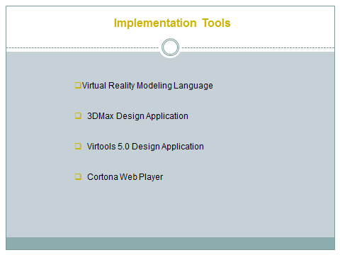

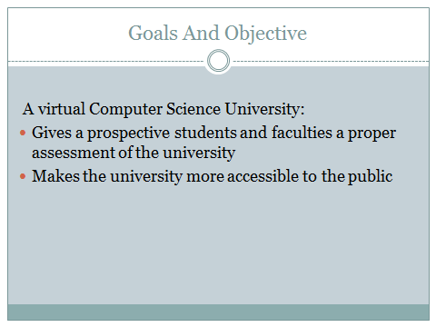

VRML Added Functionality

texture ImageTexture

{

url "wall texture1.jpg"

}

Anchor {

description ""

parameter ""

url "computerlab.wrl"

children [

DEF Plane007 Transform {

translation -1775 135.6 112.5

rotation -0.5861 -0.5595 0.5861 -2.121

scale 0.5674 1 1.04

scaleOrientation 1 0 0 -0.04645

children [

Shape {

appearance Appearance {

material Material {

diffuseColor 0.7882 0.7882 0.7882

ambientIntensity 1.0

specularColor 0 0 0

shininess 0.145

transparency 0

}

texture ImageTexture

{

url "wall texture1.jpg"

}

}

geometry DEF Plane007-FACES IndexedFaceSet {

ccw TRUE

solid TRUE

coord DEF Plane007-COORD Coordinate { point [

-1290 0 285.5, 1290 0 285.5, -1290 0 -285.5, 1290 0 -285.5]

}

coordIndex [

2, 0, 3, -1, 1, 3, 0, -1]

}

}

]

}

] }

The Design Environment include: Students walking into the department’s building, go to the hallway, enter the classroom and laboratories and back to the hall way.

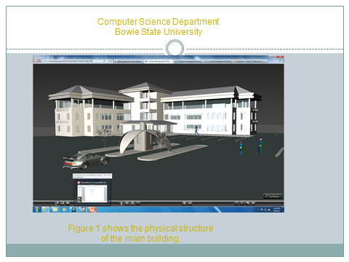

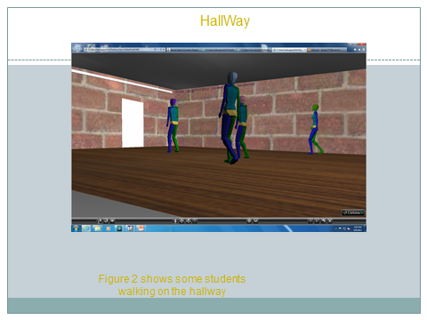

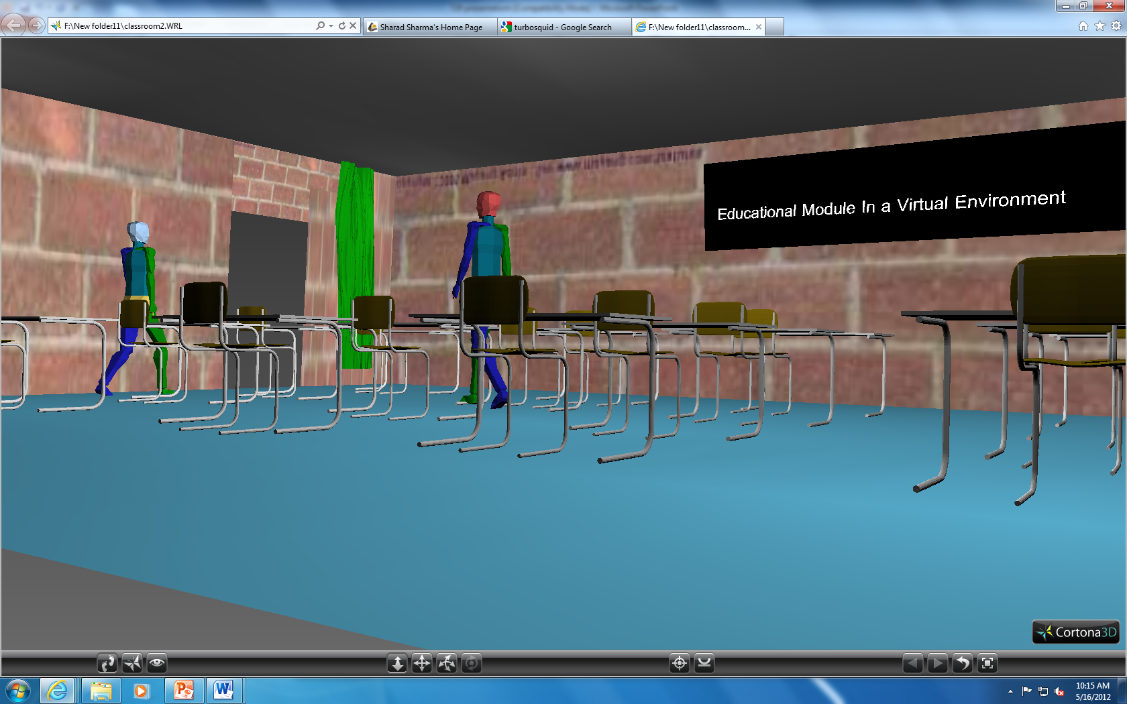

Figure 3 shows students working out of the class room into the hall way.

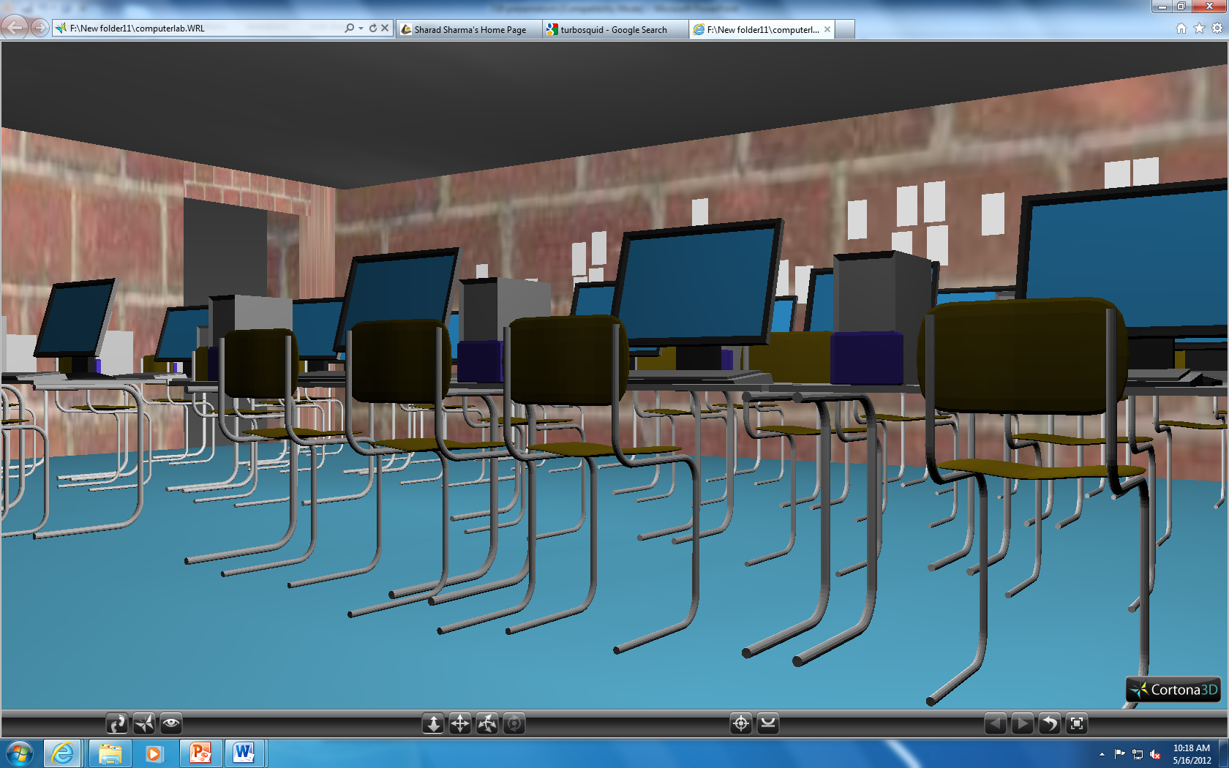

Figure 4 shows a computer laboratory.

